Report On Computer System Resources Needed For Coca Cola Company In Food Industry

Institutional Affiliation
Student Name
Professors Name
Course
Date

Report On Computer System Resources Needed For Coca Cola Company In Food Industry
The deployment of the computer has been unhurried to creep into the foodservice industry. Nonetheless; the usage of computers in the food industry is taking up the duration of dynamic growth. Some of the factors contributing to this rapid growth include rapid development and sophisticated technologies; competitive push requiring more coherent procedures, the increased availability and decreased cost of computers, and the increasing expense of food production (Hermanto, 2018). No one can overlook the importance of computers in every organization.
Computer System Resources
The computer resources are divided into two types there is there are the software resource and hardware resources. The hardware resources of a computer system consist of input resources through this data which can either be fact or raw figures are entered; the output resources by which the processed data are which is referred to as output; and the central processing unit (CPU), which facilitates the processing of data, the CPU consists of three primary components: a memory; an arithmetic and logic unit (ALU) (Noghabi et al., 2020). The software resources are a set of instructions used in executing data which includes applications.
Main Memory
The main memory is commonly referred to as RAM (Random Access Memory). There is the resource in which the instructions and data to be handled by the processor are stored is called the main memory. RAM is the internal memory of the CPU used to stores data and any program information. It is a read/write memory that stores data until the machine is working. It is volatile (Noghabi et al., 2020).
Access time in RAM is independent of the address, that is, each storage location inside the memory is as easy to reach as other locations and takes the same amount of time. Data in the RAM can be accessed randomly but it is very expensive. The auxiliary storage which is used is commonly referred to as ROM is used to store large information and is less expensive compared to RAM.ROM is nonvolatile (Noghabi et al., 2020).
Peripheral Devices
A peripheral device is generally referred to as any additional device such as a computer mouse or keyboard. Other examples of peripherals are graphics cards, image scanners, tape drives, microphones, loudspeakers, and digital cameras. RAM connects the path between peripheral and primary components; it is technically storage peripheral but is needed both in peripheral and program applications (Hermanto, 2018).
Monitor
As you compare monitors, the key is to find a monitor that you can read without undue eyestrain. The size of the monitor is very important. A large monitor is easy to read (Von Krogh, 2018).
Keyboard
As is the case with the monitor, the key issue in comparing keyboards is your comfort in using them. A supplement to the keyboard for entering work and executing commands is the mouse. These also come in various styles, so you should look for one that's comfortable and easy to use. You can choose a wireless keyboard and mouse and avoid all those cords and cables (Hermanto, 2018).

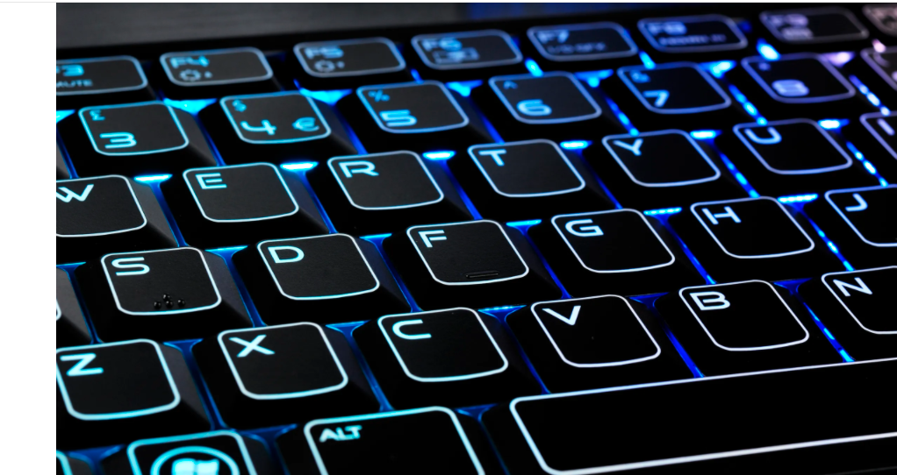
Hard drives
The hard drive is where your computer stores programs and other information on a somewhat permanent basis. With software applications continuing to grow in size, you're usually best off getting as large a hard drive as you can afford.
Printers
Printer options for a printer vary from rather slow and inexpensive (inkjet printers) to fast and more expensive (laser printers). In comparing the costs of different printers, it's important to look beyond just the initial purchase price (Von Krogh, 2018).
Work Stations
The workstations sprouts because dedicated systems settings can be configured to offer highly in client-server connection. Work stations are essential since the food industry has many functionalities different communication on different departments and branches globally.
Micro Based Mini-Computers
The current flow is to introduce less cost, mini-computer systems based on advanced microprocessor chips in a multi microprocessor architecture as multiterminal systems. The power offered by these systems is comparable to some of the super-mini-computer systems not long before. PCs are used as terminals to mini-computers. Such configurations offer the advantages of providing computing facilities in a distributed manner, with scope for centralized processing and storage facilities wherever needed (Von Krogh, 2018).
Networks
In today's usage of computer networks, Local Area Networks (LANs) are most important. More than 50% of all installed computer systems in organizations are connected to a LAN (Hermanto, 2018). This means, on the other hand, that only the organization itself is responsible for the selection and operation of their LAN. Other than with WANs or MANs there are no legal or political restrictions. LANs can be characterized with the following points:
- The network spreads over a small area, e. g. a single building or a cluster of buildings
- The network consists of one transmission medium used for all operations within the network
- The network runs at a high speed (from 1 Million bits per second to 100 Mbps)
- It is a peer-to-peer network, that is, any device within the network can exchange data with any other device
It is owned by a single organization, which is responsible for its operation LANs can be distinguished in four major points: 1. the topology of the network: bus or ring 2. The wiring layout: linear or start. 3. The used transmission medium: twisted pair, coaxial cable (baseband, broadband), an optical fiber (Von Krogh, 2018). 4. The used medium access control technique: CSMA/CD or token-passing Together these points determine the cost, capacity, effectiveness, and performance of a LAN. What is more, they determine whether two LANs can be easily connected, a necessity that has become obvious during the last few years. The single points are not independent and cannot be decided in isolation
LANs (Local Area Networks), for example, a computer network in a company's department. MANs (Metropolitan Area Networks), for example, a cable television network within a city. WANs (Wide Area Networks, Long Haul Networks), for example, an ISDN network. MAN and WANs enable global connection to other companies in terms of production and connectivity hence enhancing networked high results (Von Krogh, 2018).
Network Components
Each computer on the network must have a Network Interface Card (NIC). A NIC is the computer’s gateway to the network. The NIC attaches to the network via connection medium, usually a wire or cable, which attaches to the other computer. When there are more than two computers, their cables can connect to a hub. A hub is like the center of a tire with spokes emanating from it, each connecting to a separate computer or peripheral device. Hubs come in various sizes, defined by the number of ports or connections they offer. A switch is like an intelligent hub. A hub will broadcast a computer’s request to every device on the network, while a switch will direct the request directly to the recipient’s port. This helps relieve excess congestion and improve performance on the network (Noghabi et al., 2020). Most networks also have one or more central computers called servers. A server is a powerful version of a desktop computer.
They are designed to be the managers of the network, performing such functions as file, print and email servers. Many organizations use routers in their offices today. Routers are devices that can connect separate networks together. They can be used to connect remote offices together, or to share an internet connection within the office (Hermanto, 2018). To protect a network, a firewall is often used. Firewalls are devices that sit between your Internet connection and your network. Their function is to protect your network’s security and ensure that no one breaks into your network. Networks require Network Operating Systems. Examples of such Operating Systems include Windows NT, Windows 2000 Server and Novell Netware. Low and no-cost options are readily available as well in the form of the various versions of Linux (Daniel, 2018).
Software
The software can be categorized into systems and applications software. Widely, software that offers facilities for better usage of systems resources is called systems software. Software developed for specific application needs is called applications software. The software can be bought or in-house driven software. Web applications enhance advertising.
Operating Systems
The first and most important part of software needed for computers is the operating system (OS). The operating system acts as the immediate between the user and the hardware. This is used in resource allocation and managing processes. It enables file management, security, and CPU scheduling. Linux is a more secure operating system but is not easy to use and window OS is very easy to use but can easily be hacked (Melton et al., 2017).
Security Technologies
Internet and EC security is a thriving business and several companies have come up with technologies to enhance internet security. Examples of security technologies include:
Firewall
A firewall is a network component consisting of both hardware and software that isolates a private network from a public network (Daniel, 2018).
Intrusion Detection System (IDS)
This is a special category of software that can monitor activity across a network or on a host computer, watch for suspicious activity, and take automated action based on what it sees
Security Risk Management
A systematic process for determining the likelihood of various security attacks and for identifying the actions needed to prevent or mitigate those attacks.
As a manager, you will be responsible for developing, enforcing, and explaining corporate ethics policies. Historically, corporate management has paid much more attention to financial integrity and personnel policies than to the information systems area. But corporations should have an ethics policy in the information systems (IS) area covering such issues as privacy, property, accountability, system quality, and quality of life. The challenge will be in educating non-IS managers about the need for these policies, as well as educating your workforce (Meske & Amojo, 2019).
Some corporations have developed far-reaching corporate IS codes of ethics, including FedEx, IBM, American Express, and Merck & Co. Most firms, however, have not developed these codes of ethics, leaving their employees unsure about expected correct behavior. There is some dispute concerning a general code of ethics versus a specific information systems code of ethics (Daniel, 2018).
As managers, you should strive to develop an IS-specific set of ethical standards for each of the five moral dimensions: 1. Information rights and obligations. A code should cover topics such as employee e-mail and Internet privacy, workplace monitoring, treatment of corporate information, and policies on customer information (Noghabi et al., 2020). 2. Property rights and obligations. A code should cover topics such as software licenses, ownership of firm data and facilities, ownership of software created by employees on company hardware, and software copyrights. Specific guidelines for contractual relationships with third parties should be covered as well. 3. System quality. The code should describe the general levels of data quality and system error that can be tolerated, with detailed specifications left to specific projects. The code should require that all systems attempt to estimate data quality and system error probabilities (Force, 2018).
The fourth moral is the quality of life. The code should state that the purpose of systems is to improve the quality of life for customers and employees by achieving high levels of product quality, customer service, and employee satisfaction.
Server
In computing, a server is computer hardware or software that provides functionality for other programs or devices, called the client and the architecture is known as client–server model. Servers can provide various functionalities, often called "services", such as sharing data among multiple clients or performing computation tasks for a client (Daniel, 2018). A virtual server is also needed for backup.
CPU
This the central Processing unit which helps in processing the output. The CPU is necessary in computing since it controls all the activities of processing output. Intel core 9 is the fastest. This will be a competitive advantage.

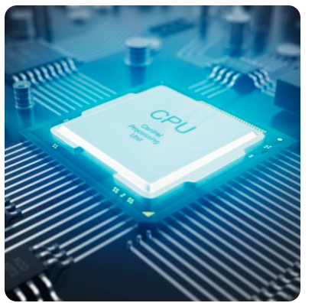

References
Daniel, C. O. (2018). Effects of marketing strategies on organizational performance. International journal of business marketing and management, 3(9), 1-9.
Force, J. T. (2018). Risk management framework for information systems and organizations. NIST Special Publication, 800, 37.
Hermanto, A. (2018). Integration of EA and IT service to improve performance at higher education organizations. In MATEC Web of Conferences (Vol. 154, p. 03008). EDP Sciences.
Meske, C., & Amojo, I. (2019). Status Quo, Critical Reflection, and Road Ahead of Digital Nudging in Information Systems Research--A Discussion with Markus Weinmann and Alexey Voinov. arXiv preprint arXiv:1911.08202.
Melton, A., Damron, T., & Vernon, J. (2017). A Marketing Strategy from Corporate Social Responsibility: Lessons from Unilever and Coca-Cola Enterprises.
Noghabi, S. A., Cox, L., Agarwal, S., & Ananthanarayanan, G. (2020). The emerging landscape of edge computing. T-Mobile: Mobile Computing and Communications, 23(4), 11-20.
Von Krogh, G. (2018). Artificial intelligence in organizations: New opportunities for phenomenon-based theorizing. Academy of Management Discoveries.

Budget for the Coca-Cola Computer System Resource
